ODF Add-in for Word 2007 - Technical Specifications

V0.1 - Prototype

TITLE |  | ODF Add-in for Word 2007 Technical Specifications
REVISION HISTORY
Revision Number | Date |  | Author(s) | Description
0.1 | July 5, 2006 |  | Project team | Initial revision for Prototype release

Table of Contents
ODF Add-in for Word 2007 Technical Specifications 1
1. Introduction 2
1.1. Purpose 2
1.2. References 2
1.3. Definitions and acronyms 2
1.4. Software requirements 2
1.5. Hardware requirements 2
2. Software architecture 3
2.1. Overall architecture 3
2.2. Components implementation 5
2.2.1. ODF Zip Utils 5
2.2.2. ODF Converter Library 6
2.2.3. ODF Word 2007 Addin 8
2.2.4. ODF Converter Test 8
2.2.5. ODF Word 2007 Setup 8

Introduction

Purpose
This document describes the technical requirements and implementation of the ODF Add-in for Word 2007. This version applies to the Prototype version.
The functional requirements of the Add-in are described in the “ODF Add-in for Word 2007 - Functional Specifications” document ([1]).

References
[1] ODF Add-in for Word 2007 - Functional Specifications

Definitions and acronyms
Expression | Definition
OOX | Office Open XML file ( “.docx” suffix for Word 2007 documents)
ODF | Open Document File
Add-in | Component that can be integrated into another application

Software requirements
The ODF Add-in for Word 2007 requires the following software to be installed:

- Either Microsoft Windows XP SP2 or Microsoft Windows Server 2003
- Microsoft .NET Framework 2.0
- Microsoft Word 2007 beta 2
The “.NET Programmability” sub-component of Word 2007 must be also installed.

Hardware requirements
The ODF Add-in for Word 2007 itself does not have special hardware requirements, but inherits Word 2007’s requirements:

Computer & Processor:
500 megahertz (MHz) processor or higher; 256 megabyte (MB) RAM or higher.

Hard Disk:
Word: depends on the selected options
ODF Add-in for Word 2007 : one additional megabyte.

Monitor Resolution:
Minimum 800x600; 1024x768 or higher recommended.

Software architecture

Overall architecture
The ODF Add-in for Word 2007 has a modular architecture in order to allow the conversion from ODF to OOX to be carried out in two ways:

- By using the Add-In itself,
- By using a command line translator.

Both options do a file conversion: the Add-In carries the conversion of the ODF file to a temporary read-only OOX file and then opens this file in Word 2007.

Note: the prototype does not remove temporary created files after Word 2007 is closed. This may change in future release of the ODF Add-in for Word 2007.

The following picture presents the overall architecture of the ODF Add-in for Word 2007.

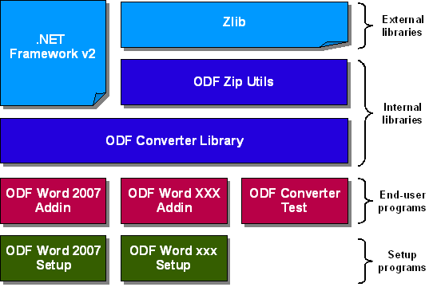

Note : As of today, there are only two end-users and one setup programs:
- ODF Word 2007 Addin,
- ODF Word 2007 Setup,
- ODF Converter Test (which is the command line translator).

Each component is implemented as a Visual Studio .NET 2005 project.

The following table presents the role of each component.

Component | Role | Project
ODF Converter Library | This is the central part of the ODF Add-in for Word 2007 ; it does the actual translation from an ODF File to an OOX file | OdfConverterLib
ODF Zip Utils | Provides a .NET API for reading and saving ZIP files. | OdfZipUtils
ODF Word 2007 Addin | Adds the “Open ODF” feature to Word 2007 ; it provides the user interface above the ODF Converter Library | OdfWord2007Addin
ODF Converter Test | Command line translator | OdfConverterTest
ODF Word 2007 Setup | Setup program for the addin | OdfWord2007AddinSetup

Components implementation

ODF Zip Utils

Both ODF and OOX are ZIP files embedding XML and resources files.
The Zlib library provides a basic and unmanaged implementation of ZIP reading and writing functions ; the ODF Zip Utils library provides a higher level (and managed) API for handling ZIP files.

In addition, the ODF Zip Utils library provides a way to package XML fragments and external binary files into a ZIP archive. It is done through ZipArchiveWriter, which is a custom implementation of System.Xml.XmlWriter.
The input XML stream must conform to the following structure:
<zip:archive zip:target="somePath">
<zip:entry zip:target="relativePath">
<!-- xml fragment to be packaged -->
</zip:entry>
...
<!-- other entries -->
</zip:archive>

The ODZ Zip Utils library contains the following classes.

Class | Purpose
ZipLib | Interop layer for zlib library
ZipReader | Abstract class for ZIP file read operations
ZipWriter | Abstract class for ZIP file write operations
ZlibZipReader | Actual implementation of ZIP file read operations: derived from ZipReader and based on ZipLib
ZlibZipWriter | Actual implementation of ZIP file write operations: derived from ZipWriter and based on ZipLib
ZipArchiveWriter | package XML fragments and external binary files into a ZIP archive
ZipEntryNotFoundException | Thrown when an entry is missing in the ZIP file
ZipException | Thrown when other errors are encounted by the Zlib library.

ODF Converter Library
The main part of the converter library consists in XSL Transformations. Those are used to convert an XML serialization of ODF into an XML serialization of OOX.
Anyway, as both ODF and OOX embed resources into ZIP files, we need to do Pre and Post Processings before and after the XSL Transforms.
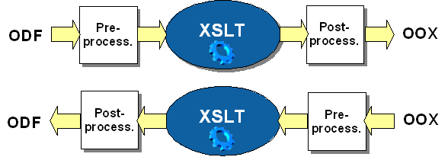
Several options are available for both pre and post-processing. The central question is about the XML Schemas that we will deal with as XSL input and output.
Input format
Both ODF and OOX are ZIP files embedding XML and resources files. As XSL transformations can only handle XML files, we have to determine how our XSLT will access embedded XML files. There were three options available:
- Unzip the whole archive and serialize all resources (XML files and binary resources) into one single XML file (including base-64 encoded binary resources);
- Unzip the whole archive and serialize all XML files into one single XML file, but keeping references to binary resources that are kepts outside the XML file;
- Implement a Custom Resolver that is used by the XSLT Processor to access the XML files on-the-fly during the transformation.
The third solution is the most performant regarding CPU and memory load, as we don't have to parse all the files once to build the XML file that will be transformed: the resources are loaded only once when they are required. This is the solution implemented in the ODF Converter Library.

Output format
The output of the XSL transformation must be a single XML file that we'll have to post-process in order to build the ZIP archive. In an OOX file, there are a lot of references to embedded XML or binary files, such as links, footnotes, images, ... In an ODF file, there are less embedded resources (only multimedia resources and embedded documents; links or footnotes are kept in-line). There were three scenarios available:
- Produce a serialized XML file which contains several blocks, each of which corresponding to a single XML file after post-processing. In this scenario, the XSL transformation replaces all links, footnotes, images, etc. with references as it will be in the final XML files.
- Keep every in-line content (links, footnotes, ... but binary resources) as it, and replace them with references during post-processing.
- Use several XSL transformations, each of them producing a resulting XML file (one for document body, one for styles, one for links, etc.).
The third scenario is very similar to the first one, except that it will lead to several XSLT Processor to be instanciated and thus CPU and memory consumption. The second scenario involves simpler XSLT than the two others, but it requires far more post-processing, including parsing the whole resulting XML. The first scenario seems to be most efficient, because it requires only one treatment on the input XML, and the post-processing is quite simple: just split the resulting XML into several files. That's the solution implemented in the ODF Converter Library.
The ODF Converter Library contains the following classes :

Class | Purpose
Converter | Controler of the conversion process
ResourceResolver | Used to locate and access embedded resources, typically xsl stylesheets embedded in the library
ZipResolver | Used to locate and access zip resources, typically document parts
NotAndOdfDocumentException | Exception raised when the file to convert is not an ODF document

ODF Word 2007 Addin
This component provides an user interface for the ODF Converter in Word 2007:

- it add an “ODF” menu with a “Open ODF…” menu item,
- it then provides a file selection dialog box allowing the user to select one or more files to be converted and opened
- it displays for each conversion a progress dialog with the option for the user to cancel the conversion.

This component is build of two classes:

Class | Purpose
Connect | Provides the integration into word and controls the conversion process
ConvertForm | Provides the progress user interface with the cancel button

ODF Converter Test
This component is the command line translator. It currently offers the possibility to either convert an ODF file or to validate the XML schema of a resulting file.

This component is build of two classes:

Class | Purpose
OdfConverterTest | Entry point of the translator; parses the parameters and launch the conversion process
OoxValidator | Validates the schema of a result file

ODF Word 2007 Setup
This component is the installation program for the ODF Add-in for Word 2007. It copies the required components as well as the readme file in the target directory.

Needed by Word 2007.

